Test Report

The test's are outlined in the test spec documentation version 1.3 for both java and web. This is the java side of the testing and is an overall summary of how the testing went.

The tests were done on a *Samsung Galaxy Note* *3* running Android 4.4.2 *KitKat*.

The tests are labeled with identification IDs in the format "*JT#"* referring to it being a Java Test, followed by the numeric ID of the actual test being conducted. The specification requirements are also listed by their original requirement ID, e.g. "*FR1.*"

The tests are in order as follows:

Test ID: JT1

Spec Requirement: FR1

Test: Check that the software starts first time without errors on an Android device.

Info: Does RPSRrec install correctly and start up when it is tapped by the user. If the user cannot start RPSRrec due to a crash, the test fails.

Result: Test Successful. The Android App installs correctly and then starts up without error.

Test ID: JT2

Spec Requirement: FR1

Test: Check that the software starts second time with intended behaviour on an Android device.

Info: If RPSRrec is closed, can it be re-launched in the manner shown in Test JT1.

Result: Test Successful. RPSRrec can be exited and re-launched without a crash.

Test ID: JT3

Spec Requirement: FR1

Test: Check that the software allows to record at a different site once a recording has ended.

Info: The user finishes one visit recording, then attempts to start another.

Result: Test Success. The user can start a new visit recording directly after sending a previous one to the webserver.

Test ID: JT4

Spec Requirement: FR1/2

Test: Check that the user will be prompted for contact details at first boot up.

Info: A window pops up asking the user to give their contact details over to RPSRrec so it can store the data with the recording on the server. Screen Shot: 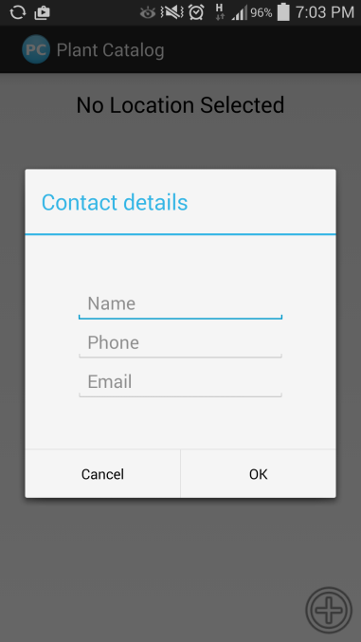

Result: Test Success. Yes, the prompt comes up for the contact information.

Test ID: JT5

Spec Requirement: FR1/2

Test: Check that reserve updates made on RPSRview are accessible to RPSRrec.

Info: Is RPSRrec downloading new information updates about reserves from the website and displaying them to the user.

Screen Shot: 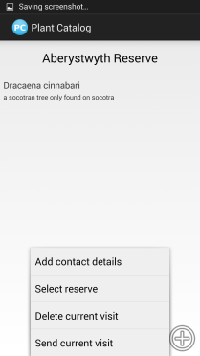

Result: Test failed. Reserve update function not visible to user.

Test ID: JT6

Spec Requirement: FR1/2

Test: Check that reserves are not downloaded when no updates are available.

Info: No new reserves downloaded, but successful boot of RPSRrec.

Result: Test Failed. Updates cannot be performed as there is no reserve update feature available.

Test ID: JT7

Spec Requirement: FR1/2

Test: Check that when network connection is not available, RPSRrec does not try to download reserve updates.

Info: RPSRrec should check to see if there is an internet connection, and when there is not it should not attempt to download any updated Reserves list.

Screen Shot:

Result: Test Failed. RPSRrec does not test for an active internet connection.

Test ID: JT8

Spec Requirement: FR2

Test: Check that no numbers are allowed in the name of the user details.

Info: The name field for the Contact Details dialogue should only allow the characters a-z and A-Z.

Screen Shot: 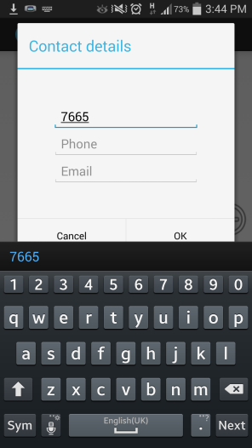

Result: Test Failed. You can enter numbers into the name field.

Test ID: JT9

Spec Requirement: FR2

Test: Check that only numbers are allowed to be entered as a phone number.

Info: Only numerical digits should be allowed to be typed into the Phone Number field of the Contact Details dialogue.

Screen Shot: 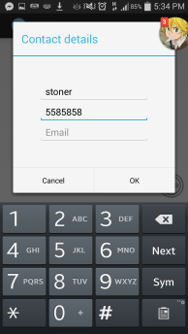

Result: Test Success. You can only enter numbers into the phone field.

Test ID: JT10

Spec Requirement: FR2

Test: Check that the user email is only allowed if it has a sensible format.

Info: The field for the email address in the Contact Details dialogue box should only accept strings of text that fit the "@[url]" email standard.

Screen Shot: 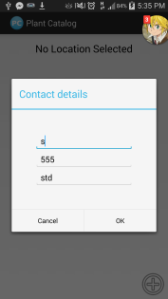 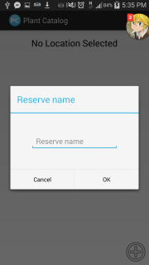

Result: Test Failed. You can enter anything you want into this field and it will be accepted.

Test ID: JT11

Spec Requirement: FR3

Test: Check that the user is able to select a species from the provided list.

Info: When recording a sighting, there should be a list of known species available to select from.

Screen Shot: 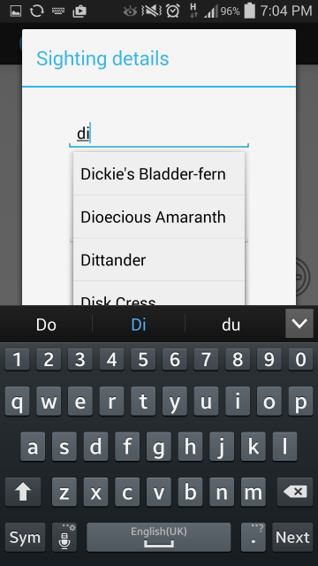

Result: Test Success. You can choose a pre-existing species from a list that drops down from the field.

Test ID: JT12

Spec Requirement: FR3

Test: Check that the user is able to add sightings of species not present in the provided list.

Info: The user should also be able to add new species to the species record and send them as part of the recording.

Screen Shot: 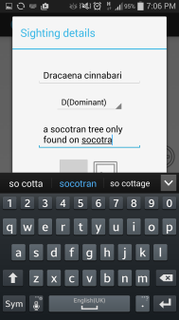 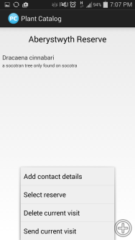

Result: Test Success. The user can add a brand new species to the list.

Test ID: JT13

Spec Requirement: FR4

Test: Check that the GPS coordinates are obtained correctly from the Android OS.

Info: If the Android OS' location service is turned on, RPSRrec should display the current GPS co-ordinates on the screen.

Screen Shot: 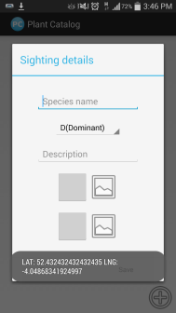

Result: Test Success. RPSRrec does display the co-ordinates if available.

Test ID: JT14

Spec Requirement: FR4

Test: Check that the radio buttons for the abundance store the correct data.

Info: There should be a drop down which has the correct DAFOR abundance values listed.

Screen Shot: 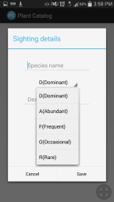

Result: Test Success. You can select the abundance level of plants and update them accordingly.

Test ID: JT15

Spec Requirement: FR4

Test: Check that the user is able to add a free text comment.

Info: The user can write a text comment about the sighting in a provided text field.

Screen Shot: 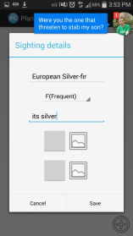

Result: Test Successful. The user can send a comment about the sighting.

Test ID: JT16

Spec Requirement: FR4

Test: Check that the user is able to add a photo from the phones gallery for the general scene.

Info: The user is meant to be able to select a photo from the gallery and add it to the species recording.

Screen Shot: 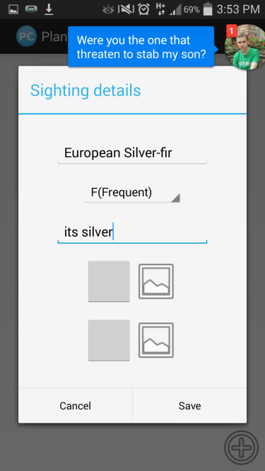

Result: Test Failed. There is no option to select from gallery.

Test ID: JT17

Spec Requirement: FR4

Test: Check that the user is able to shoot a new photo using the phones camera for the general scene.

Info: The user should be able to take an optional picture of the area around the species being recorded.

Screen Shot: 

Result: Test Failed. The taken image is displayed but is not sent to the server.

Test ID: JT18

Spec Requirement: FR4

Test: Check that the user is able to add a photo from the phones gallery for the species.

Info: The user is meant to be able to select a photo from the gallery and add it to the species recording.

Screen Shot: 

Result: Test Failed. There is no option to pick from gallery.

Test ID: JT19

Spec Requirement: FR4

Test: Check that the user is able to shoot a new photo using the phones camera for the species.

Info: The user should be able to take an optional picture of the species being recorded.

Screen Shot: 

Result: Test Failed. The taken image is displayed but is not sent to the server.

Test ID: JT20

Spec Requirement: FR5

Test: Check that the user is able to delete one species from a recording.

Info: The user should be able to remove a species from a recording through the edit function of RPSRrec.

Screen Shot: 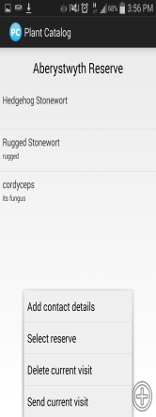 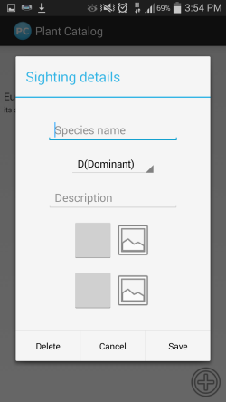

Result: Test Success. The User can delete species if RPSRrec has not already sent the recording.

Test ID: JT21

Spec Requirement: FR5

Test: Check that the user is able to delete a whole recording.

Info: The user should be able to delete an unsent visit recording from RPSRrec, thus preventing it from being sent.

Screen Shot: 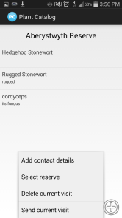 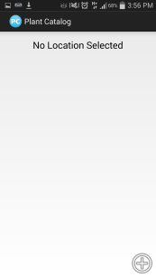

Result: Test Success. The user can delete a visit recording before it is sent.

Test ID: JT22

Spec Requirement: FR5

Test: Check that the user is able to update an un-submitted recording.

Info: Any visit recordings that have yet to be sent to the web server should be accessible for editing by the user.

Screen Shot: 

Result: Test Partial-Success. The user can edit a recording before it is sent. However there is no visible button and the user must know to hold down the recording.

Test ID: JT23

Spec Requirement: FR6

Test: Check that recording is sent with network connection available.

Info: When the user presses the send button with an internet connection available, all stored recordings should be uploaded to the web server.

Screen Shot: 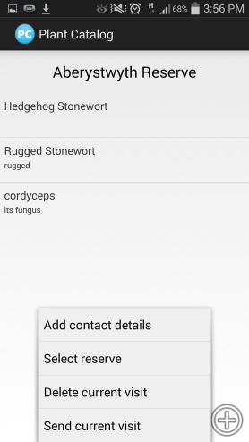 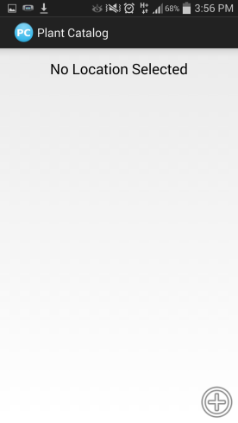

Result: Test Failed. The Recording is sent via an internet connection but no message pops up telling the user the data has been sent successfully.

Test ID: JT24

Spec Requirement: FR6

Test: Check the recording is not sent without a network connection.

Info: If there is no network connection, RPSRrec will display a message to the user informing them that the recordings could not be sent due to a missing internet connection.

Screen Shot: 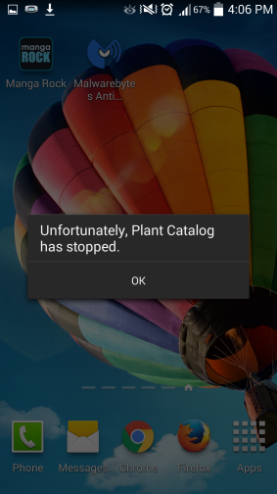

Result: Test failed. RPSRrec does attempt to send the data, and instead of warning the user it simply deletes the records.